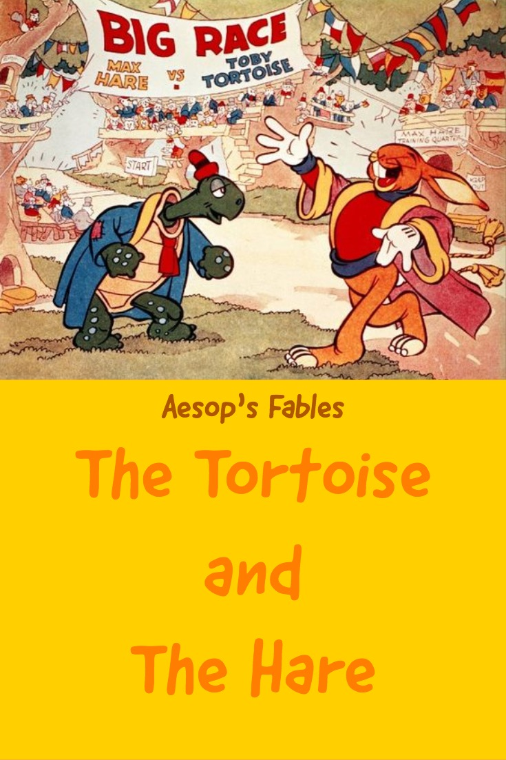

**The Tortoise And The Hare**

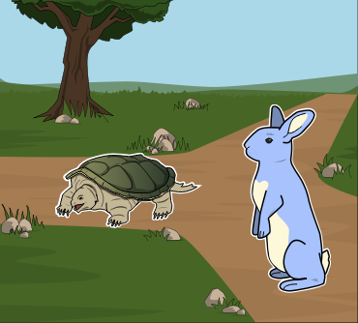

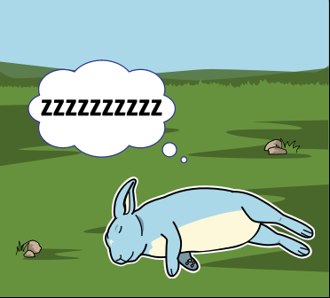There once was a speedy hare who bragged about how fast he could run. Tired of hearing him boast, slow and Steady, the tortoise, challenged him to a race. All the animals in the forest gathered to watch. In the middle of the race, hare decides to take a nap thinking that there is still plenty of time since the tortoise walks so slow. Slow and Steady walked and walked. He never, ever stopped until he came to the finish line.

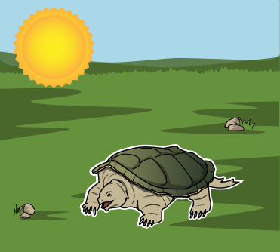

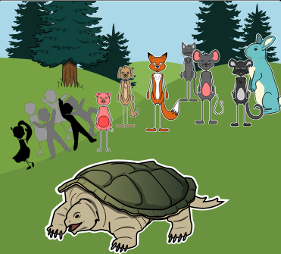

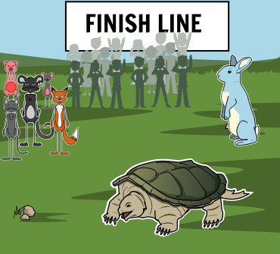The animals who were watching cheered so loudly for Tortoise, they woke up Hare.Hare stretched and yawned and began to run again, but it was too late. Tortoise was   
  
over the line. After that, Hare always reminded himself, "Don't brag about your lightning pace, for Slow and Steady won the race!"